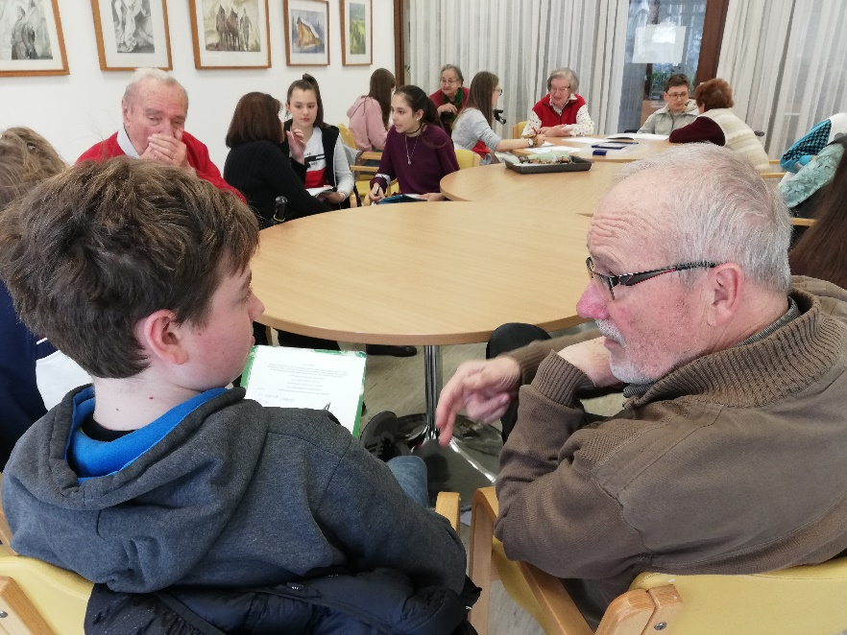
An Interview with Mr Janez Debeljak
In the conversation with Mr Janez Debeljak we concentrated on the present day school system. Mr Debeljak emphasised the relevance of gradual learning. He feels strongly opposed the excessive quantity of information the modern youth is obliged to process and acquire nowadays, much of it being completely irrelevant (eg. dates of important events, biographies of writers and the like). We concluded that present school system’s curriculums are too extensive to be effectively taught in such short periods of time as are available during primary or secondary school education. Interestingly, Mr Debeljak believes we should not dedicate our time to the contents of the curriculum we are not interested in simply for the sake of acquiring general knowledge. On the contrary, we should dedicate our precious time to our dreams and interests and, most of all, our relationships, which are often neglected.
Despite all the problems of modern and past era Mr Janez and I were debating about, we concluded in a positive spirit with a realisation that despite the age difference we are not that different at all.

After the interview I asked Mr Debeljak to write a message for the young people today and he took quite some time and serious consideration to do it and we would like to thank him for his effort and kidness.
This is what he would like to share with us:
1. Nurture relationships.
2. Technology cannot replace relationships.
3. You should look for the subjects of interests within yourself and then dedicate more of your time to them.
4. You should avoid conflicts at school and in life in general.
5. Progress can only be achieved by lots of effort and hard work.
6. You should respect your peers and the teachers with respectful and professional approach.

By Arne Kolenc Šušteršič

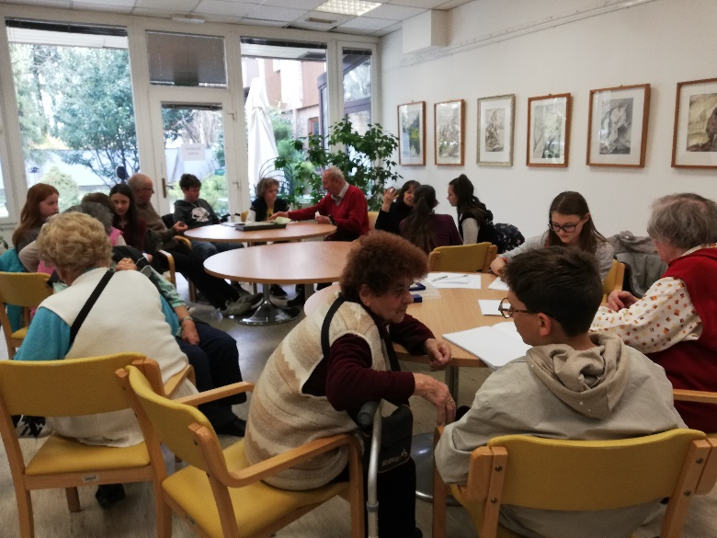
An Interview with Mrs Jožica Strniša

As a part of our project in cooperation with Gimnazija Vič, our school organized a visit at an Old People's Home Kolezija.
So one Thursday afternoon we went there. Each one of us interviewed one person.
I had an interview with Jožica Strniša.
Jožica Strniša was born in a countryside to her parents whom she respected a lot. Before she started attending school, she worked a lot at home but she liked working, so it didn't bother her.
When she started attending primary school, there were 4 classes in Slovenian language and 4 classes in German language. She participated in a lot of projects and she was always praised, that meant her a lot.
Later she had an opportunity to attend a high school in Ljubljana and she took it. Jožica explained that it was easier to be accepted at high school then than now.
Later she joined a working brigade. She also studied trade.
Afterwards she worked for a company which had a vacation home, so employees could go there on holidays. That is to say, back than there weren't many opportunities to go abroad.
She worked for that company for 35 years and it was a wonderful experience for her. She also told me that she participated in a lot of events.
Than we talked a little bit about the world now. She thinks that nowadays parents don't care about their kids as much as they used to. They don't seem to have any influence at all. However the world must be accepted with all its changes.
Jožica also said “I have a really wonderful life, I can't complain about it,” and “You just have to have the will to do it”.
I asked her if she has any advice for people/ kids and teenagers nowadays and she said “Work forms a person,” also “Live a fair life,” and “ Life is beautiful if you make it that way.”
It was really nice talking to Mrs Jožica Strniša because she was a really positive person. Many teenagers think that the elder people complain all the time. But after talking to this lady I can say that's not true.

By Daša Vilar

An Interview with Mr Viktor Rus

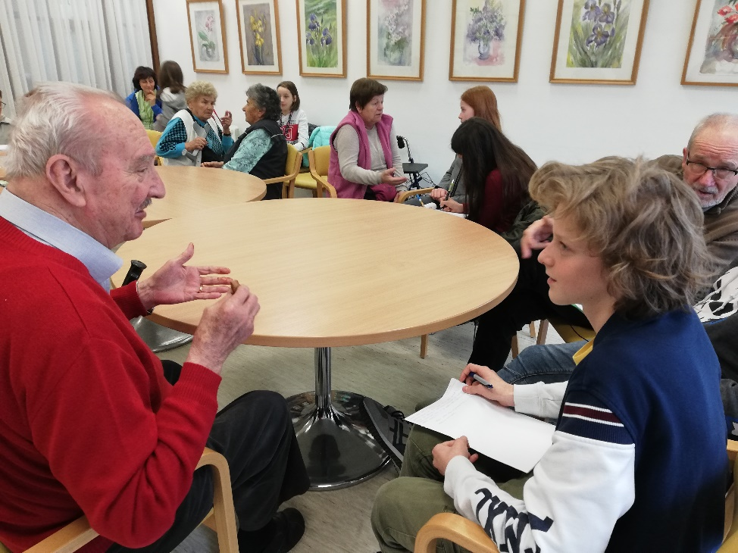
One Thursday, after classes we and our English teacher went to the old people's home, where we had a perfect chance to talk to old people and learn something interesting from their past lives, when they were as old as we are now.
I talked with Viktor Rus, who was really nice. He told me lots of stories from his past and also he revealed a message that he wants us, the youth of today, to remember.
The first thing that surprised me when I started talking to Mr Viktor was that he was addressing me with “Sir” during our conversation.
Mr Rus told me how much harder life was in his childhood than it is today, at least for a school boy. He needed to take a train every single day and then walk for additional 8 km to come to school, because his mom was disabled and his dad was working hard in a factory all day long. His family also didn't have enough money to hire a room for him somewhere near school. However, his high school was in a walking distance from his home, so life became simpler and less tiring during his high school period.
As for the young people of today, Mr Rus believes we need to make careful choices, because the entire world depends on us. The message that he wants to pass on us is that we have to take the next step if we want to make the world a better place to live. In addition, he believes that the technology we possess (mobile devices, computers, tablets and other smart gadgets) is just the tool that helps us a lot but does not replace and can't replace our social lives.
I was really surprised by how people treated us during our visit at the Old People’s Home Kolezija. They paid a great deal of respect to us simply by addressing us Sir or Mrs, which has never happened to me before. Also, I really appreciated their interest in talking to us, because they could easily refuse it or roll their eyes all the time. I was also shocked by their determination and bravery, when they were young. They were mostly living hard, poor lives and what’s even worse, struggling to survive during World War II. I admire and respect them greatly for that.
After the conversation with Mr Viktor Rus, I also talked to my gradpa about his life. He had similar experience as Viktor. He was struggling to survive during 2nd world war, and one day a bomb fell from the Italian bomber and landed directly in the middle of the classroom, in which my grandpa was. All of the students and the teacher were looking at that bomb, but it did not explode. Can you imagine how lucky they were?
Many people think that old people are usually depressed and annoying living beings. But that is not true. They respect everyone around them, and they are usually the wise people, the people, who can tell you lots of interesting and heart-breaking stories. They are the people, whose advice is worth listening to. We need to respect each other, and the old people are often the ones, who bring us hope of living a better life in better place with better people.

By Gašper Roblek

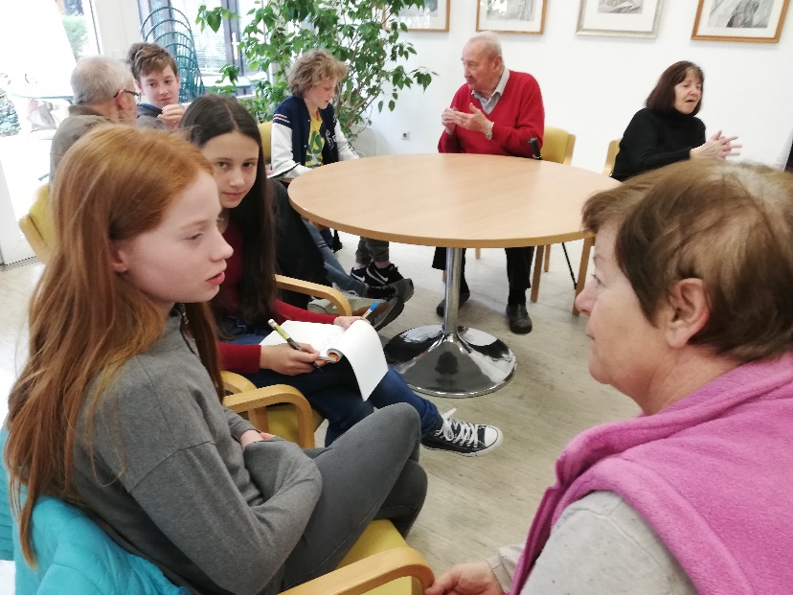
Interview with Mrs Mihaela Kacjan

Where did you spend your childhood?
I lived in Ljubljana, in Rudnik.
Could you tell me more about your family?
I had three brothers and two sisters. One brother died in a car crash. We all grieved for a very long time. My mom was a very kind person and my dad was very strict. I was often afraid of him.
What was your attitude towards school?
I liked going to school. I was the best in the class till the fourth grade. I liked doing homework, even when there was a lot of it. There is another thing that I can remember; for some reason the teacher of Slovenian didn’t like me. Once, when sitting for a test, I copied the answers from my schoolmate, so we had identical answers. The teacher gave me a two and my schoolmate got a five.
What where the punishments like at school?
There were no corporal punishments, but sometimes we were sent to stand in the corner.
What did you like to do in your free time?
I liked doing sports and playing board games with my neighbours, schoolmates and other friends.
Where did you continue your schooling and why?
I went to the nursing school. I wanted to become a doctor because I wanted to help people.
Was there anything special that you wished for when you were little?
No, not really. I was a very modest child and I knew that I couldn’t just ask for things.
Could you tell me something about your husband?
I met him at the nursing school. He was from Ribnica.
Were you happy together?
Yes, we were, but then he got cancer and died. His wish was to die at home and I took care of him. I nursed him, I cooked his favourite meals … He died in our matrimonial bed, only sixty – five years old, and since then I have never been afraid of a dead person again.
In your opinion, what are the main differences between being young in the past and being young today?
Nowadays the children can get almost everything they want and their parents can help them in various ways.
What kind of advice would you give us?
Choose your future profession wisely so that you will be happy to do it every day.

by Ronja Vendramin Vesel and Gaja Klun

An Interview with Mrs Ivana Gieher

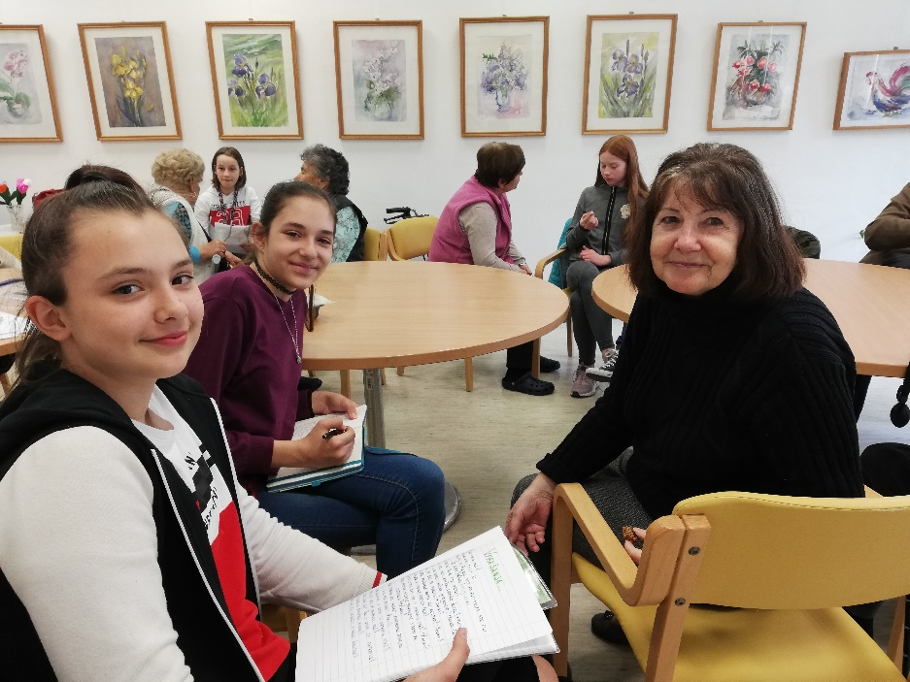
On Thursday, March 28th, 2019, we visited some nice people at Old People’s Home Kolezija who were ready to talk to us about their youth and our experience of being a teenager.
We interviewed Mrs Ivana Gieher, a seventy-six-year-old retired teacher, who has been living at the old people’s home for about a year and a half now.
She was born in a family with four children, all girls. As a child, she was lucky to be surrounded by different animals, such as kittens, horses and cows.
Her idea of free time was much different from the one youngsters have nowadays. That is to say, when she had no obligations at home or for school, in summer in particularly, she and her friends would walk to the local stream and swim there, and they had a really great time.
After secondary school, she attended higher education and became a teacher, which had always been her wish. She was inspired by her primary school teacher whom she really liked.
Writing poems and strolling around the old city of Ljubljana is something she likes doing very much.
As for food, she favours beef soup and all sorts of desserts.
When we asked her about her opinion of young people, she surprised us by saying that they are just like young people were in her youth. The only difference is the period they live in.
We would like to thank Mrs Ivana for chatting to us in such a pleasant atmosphere.

By Zala Ukmar and Natalija Šarkezi

An Interview with Mrs Mojca Šegatin

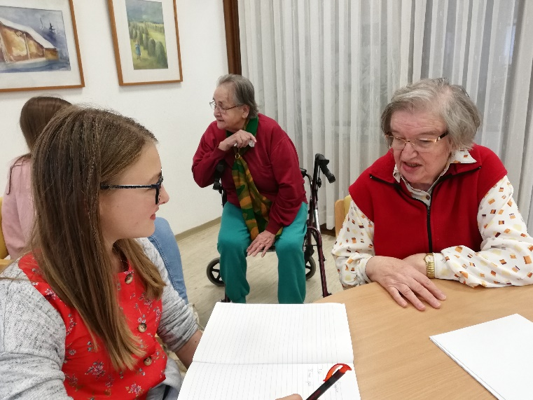
Devi: What is your name?
Mojca: My name is Mojca Šegatin.
D: How old were you when you started school?
M. I was 7 years old.
D: Where did you go to school?
M: I went to Primary School Prule in Ljubljana. It was a great school.
D: Did you train any sports?
M: Yes, I trained handball.
D: Were there any severe punishments at your school?
M: No, the punishments were similar to yours. Physical punishments were not allowed.
D: What were the hardest subjects?
M: The hardest subjects were Maths and different languages. English was not as widely spread as today so I did not get the chance to hear it on the radio.
D: What did you do during the holidays?
M: I went on different trips with my parents: The one I remember the most is when we went hiking in the Alps.
D: How long did you have school for?
M: We had school from 8 am. to 12:30 pm., similar to your schedule today.
D: What was your job?
M: I was a construction engineer. I helped build roads, bridges and many buildings in Ljubljana.
D: How long were you a construction engineer for?
M: I was a construction engineer for 35 year. I really enjoyed my work.
D: How old are you?
M: I am 72 years old.

By Devi Kuščer

An Interview with Mrs Katica Mir

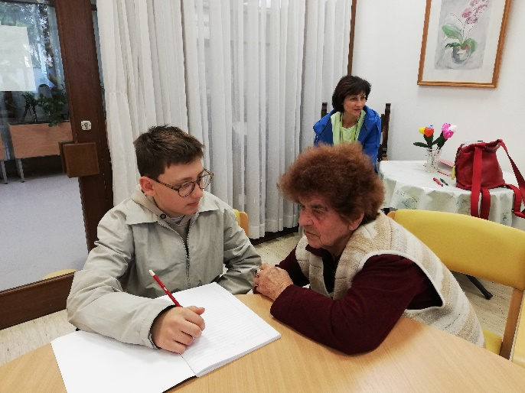
Thank you for taking your time. We want to ask you some questions. First, which were your biggest wishes, when you were young?
Our teachers and parents were beating us if we weren´t good at school, so we wished for good grades and no problems. I lived in the countryside – I had to work on a farm. We wished for free time, to play with friends.
How many classes did you have at school?
I had four classes, but I had to work on a farm, when I came home.
What about discipline at your school, was it strict?
Yes, it was very strict. We had religious education on Mondays with a priest, who was beating us. We
didn´t have any meals at school, we were only eating at home.
Did you celebrate any holidays?
Only few, like Christmas or New Year... The whole family got together and we had a family dinner.
We didn´t have so many work – free days, as you do today.
How much time did you spend with your friends, when you were young?
Very little. We didn´t have much free time. We were seeing each other only when were grazing animals in pastures.
That´s all. Thank you.
You´re welcome.
By Miha Bregar
An Interview with Mrs Ljudmila Pelko and Milena Osredkar

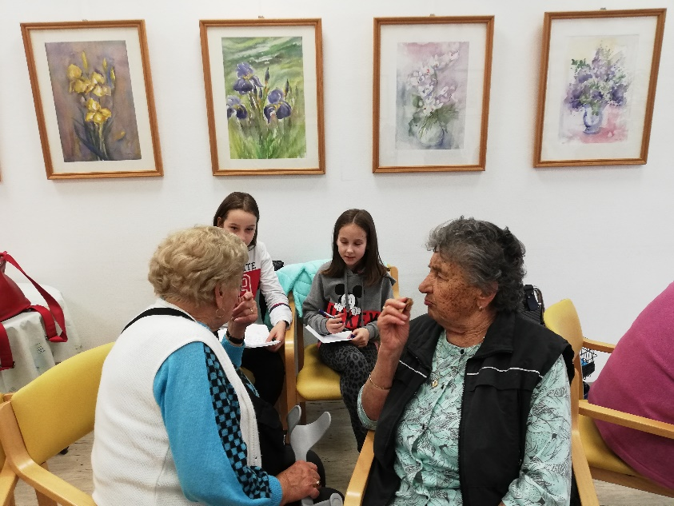
Back then we didn't have any free time.We had to work in the field and help our parents after school. We really enjoyed climbing trees though after we finished with our work.
At school we had different subjects, such as reading, calculating, Srbo-Croatian, hand-writing, reciting and conduct.
We didn't have meals at school; we brought some snacks along and then we had lunch at home. School started at 8 and finished at 12.
There were no children with bad attitude at school then because we were afraid of the severe punishments. If we misbehaved, we had to kneel on corn in the corner of the classroom,a slap with a ruler and alike.
It was pretty easy to get a job in our youth.
The most important rule we followed in our lives was to be kind and respectfull.
Their message to us was:
Respect your mother and father so that you will live well and you will be content.

by Klara Gorkič and Nika Kapitanovič.

